TUTORIAL 4: Creating Unstructured Grids in MD_SWMS

Create Mesh
Figure 1. The Create Mesh toolbar.

The Create Mesh toolbar (fig 1) provides a selection of tools for building unstructured triangular meshes. MD_SWMS uses Triangle, a free and open source tool for quality mesh generation and Delaunay triangulation (see: http://www.cs.cmu.edu/~quake/triangle.html). It is recommended that you spend some time on Triangle's website reading the documentation and examples and a summary of Triangle presented Section 1.4.6.1. MD_SWMS simply creates input files for use in Triangle as presented on the website. In addition to the Triangles website, the user is encouraged to work through the Mesh Building tutorial. The Create Mesh toolbar provides tools to define the mesh boundary, holes within the mesh, edge constraints, and local regions of mesh refinement. In addition, boundary conditions such as stage and discharge can be applied to the mesh boundary.

Strategy for building a simple unstructured mesh
To activate the Create Mesh Tool, the user must select from the menu, Grid/Mesh -> 2D Unstructured Mesh. This will add the Create Mesh branch to the Grid and Input Conditions branch of the data tree in the Control Bar.
An unstructured mesh is created by first defining the mesh boundary using the Create Mesh Boundary tool. Click this button and draw a polygon defining the grid boundary - hit enter when done. The mesh is the created in the following steps:

- Right click on Grid and Input Conditions | Create Mesh (Figure 2) in the Control Bar and select Create Mesh from the pop-up menu.
- If this is the first time the Create Mesh command is used (otherwise skip to step 3) then the Choose Mesh Name and Location dialog will appear from which you will browse to an appropriate location (such as the folder containing the topography data) and then enter the name of the file used as input to the Triangle tool. A good choice might be "Mesh" for the name of the file. The .poly extension is added to the file by default.
- Following step 2, the Create Mesh Dialog will appear (Figure 3). This dialog allows you to specify parameters for angle and area constraints. You must check the boxes associated with each if you would like them to apply. The quality meshing constraint imposes a minimum angle for each triangle and the area constraint imposes a maximum area for each triangle (Table 1)
- Selecting OK will run Triangle whose progress is reported through a DOS console. When it is finished the Open Triangle Node File dialog appears and you will select the appropriate *.node file. If you entered "Mesh" in step 2, then you would select the Mesh.1.node file to open. The resulting triangulation generated in Triangle will then be loaded into MD_SWMS and be available for viewing.
- At this point the spatial location and geometry of the mesh has been defined but there are no input conditions associated with it, so you will want to map the topography to the grid (see section 1.5.4 Preprocessing Menu).

Working with Create Mesh in the Control Bar
The Grid and Input Conditions | Create Mesh branch of the Data Objects tree in the Control Bar provides access to the properties of the Create Mesh tools.
- Access Mesh Tools toolbar: To access to the Create Mesh Tools toolbar both the Grid and Input Conditions and Create Mesh branch of the Data Objects tree must be turned on by checking their respective boxes. Each time an element of the Mesh, such as a Mesh Hole, is added to the mesh an appropriate branch will be added to the data tree, for example, Create Mesh | Mesh Holes | Hole_0.
- Access Mesh component properties: To access the properties or delete an individual component of the mesh simply right click on the component. For example, to access the properties or delete a Mesh Refinement polygon, right click on Grid and Input Conditions | Create Mesh | Mesh Refinements | Refinement_0. This will bring a pop-up dialog to access its properties or delete the polygon.

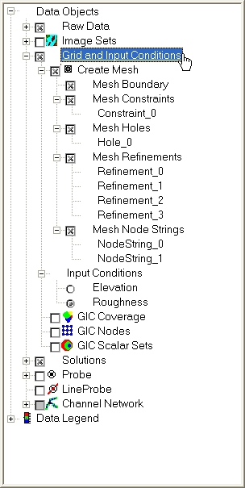  Figure 2. Grid and Input Conditions branch of the Data Objects tree showing the layout for the Create Mesh branch. | 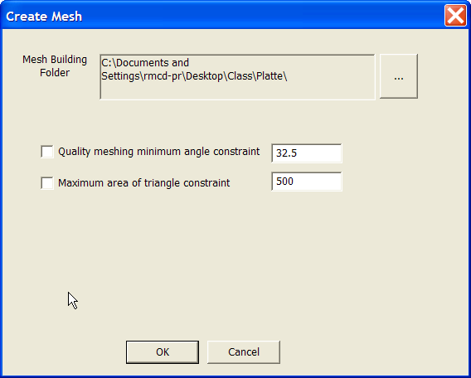  Figure 3. Create mesh dialog
Mesh Constraint | Definition from Triangle Documentation
Quality meshing minimum angle constraint | Quality mesh generation by Delaunay refinement (a hybrid of Paul Chew's and Jim Ruppert's algorithms). Adds vertices to the mesh to ensure that all angles are between 20 and 140 degrees. An alternative bound on the minimum angle, replacing 20 degrees, may be specified after the `q'. The specified angle may include a decimal point, but not exponential notation. Note that a bound of theta degrees on the smallest angle also implies a bound of (180 - 2 theta) on the largest angle. If the minimum angle is 28.6 degrees or smaller, Triangle is mathematically guaranteed to terminate (assuming infinite precision arithmetic--Triangle may fail to terminate if you run out of precision). In practice, Triangle often succeeds for minimum angles up to 34 degrees. For some meshes, however, you might need to reduce the minimum angle to avoid problems associated with insufficient floating-point precision.
Maximum area of triangle constraint | Imposes a maximum triangle area. If a number follows the `a', no triangle is generated whose area is larger than that number. If no number is specified, an .area file (if -r is used) or .poly file (if -r is not used) specifies a set of maximum area constraints. An .area file contains a separate area constraint for each triangle, and is useful for refining a finite element mesh based on a posteriori error estimates. A .poly file can optionally contain an area constraint for each segment-bounded region, thereby controlling triangle densities in a first triangulation of a PSLG. You can impose both a fixed area constraint and a varying area constraint by invoking the -a switch twice, once with and once without a number following. Each area specified may include a decimal point.
Table 1. Create Mesh Dialog Properties

Mesh Boundary: This set of two tools are used to define and edit the location of the mesh boundary. The first tool, the Create Mesh Boundary tool, is selected to define the mesh boundary by using the left mouse button to define the boundary and selecting Enter when finished. The location of a point on the mesh boundary can be adjusted with the second tool, the edit Mesh Boundary tool. To do this the boundary must be selected from the Create Grid and Input Conditions | Create Mesh | Mesh Boundary branch of the Data Objects tree in the Control Bar. Once selected the tool will become active and a point on the mesh boundary polygon can be moved by selecting with the left mouse button and dragging to a new location.
Mesh Hole: This set of two tools are used to define and edit the location of holes within the mesh. The Create Hole tool is the first tool and is selected to define a polygon whose interior will contain no nodes associated with the mesh. The Mesh Hole is defined by using the left mouse button to define the location of the hole and selecting Enter on the keyboard when finished. The center of mass of the Mesh Hole polygon is used to define a location which the Triangle algorithm uses to begin deleting triangles from the mesh boundary. Triangles are eaten until they reach the line segments defined using the Create Hole tool. Care should be taken. If another set line segments from a Mesh Constraint line or Mesh Refinement polygon are encountered first, then the hole will stop at that line segment rather than the line segments created by the Mesh Hole polygon. In other words, line segments from either a Mesh Constraint or Mesh Refinement polygon should not intersect the Mesh Hole polygon. The location of a point on the Mesh Hole polygon can be adjusted in a similar manner as adjusting Mesh Boundary points (see Mesh Boundary above).
Mesh Constraint: This set of two tools are used to define and edit the location of Constraint lines. A Constraint line is an edge whose presence in the triangulation is enforced. The first tool is used to create the Constraint line by using the left mouse button to define the location of the line and selecting Enter on the keyboard when finished. The location of a point on a Constraint line can be adjusted in a similar manner to adjusting Mesh Boundary points (see Mesh Boundary above).
Mesh Refinement: This set of two tools are used to define and edit the location of Mesh Refinement polygons. A refinement polygon defines a region with a different area constraint on the triangles from the Mesh Boundary. For example, a user could choose the triangles to have a maximum area of 100 meters squared within the mesh boundary and choose 10 meters squared within the Mesh Refinement polygon. The first tool is used to define the polygon using the left mouse button and selecting Enter on the keyboard when finished. As in the Mesh Hole, the region in which the mesh is refined begins from the center of mass of the Mesh Refinement polygon. Triangles are refined around this region until the edge of the Mesh Refinement polygon is encountered. If another set of constraints from a Constraint line or Mesh Hole are encountered first then the refinement will stop at these constraints rather than the Mesh Refinement polygon. The maximum area for each triangle within the Refinement polygon can be specified by right clicking on the appropriate branch of the data tree in the Control Bar, for example, Create Grid and Input Conditions | Create Mesh | Mesh Refinements | Refinement_0, select properties and enter the maximum area in the Refinement Maximum Area dialog (Figure 4). The second tool can be used to adjust the location of the Mesh Refinement polygon in a similar manner to the Mesh Boundary (see Mesh Boundary above).

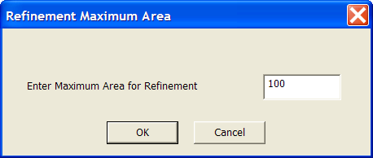
Figure 4. Refinement Maximum Area dialog. Enter the maximum area of triangles within the Mesh Refinement polygon.
Mesh Node Strings: This set of tools is used to define model boundary conditions. Currently the first tool is used to select a string of nodes that will be used as a boundary condition to the currently selected model. The string of nodes must be selected by using the left mouse button to click on successive boundary nodes. If a node is skipped within the string of nodes then an error may be generated upon running the model. The boundary condition applied to the nodes string is created by right clicking on the appropriate node string branch within the Control Bar, for example, Create Grid and Input Conditions | Create Mesh | Mesh Node Strings | Nodestring_0, and selecting the Assign Boundary Condition from the pop-up menu (Figure 5). The Boundary Condition Type is specified by selecting the button with the ellipses and selecting the type from the pop-up menu. The stage or Discharge value is entered in the BC Value field.

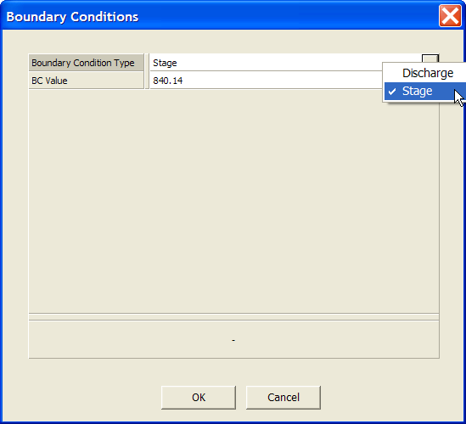
Figure 5. The Boundary Conditions dialog.

Tutorial 4 - Unstructured Mesh Generation
In this tutorial you will use the modeling system along with measured topography to construct simple unstructured triangular meshes suitable for simulations using SToRM. You will work with the TIN of the raw elevation data and use breaklines to improve the TINs representation of the data. You will use the Meshing Tools to build an unstructured mesh and then define boundary conditions. You will run SToRM and visualize the results.

Tutorial 4 steps:
- Working with Elevation TIN and Breaklines
- Meshing Tools
- Defining Boundary Conditions
- Running SToRM
- Visualize Results

Part A - Working with Elevation TIN and Breaklines
In this section of the tutorial you will become familiar with the steps involved in importing a measured set of elevations. For the purposes of this exercise, the elevation data set is contained in an external data file with extension .tpo that will be imported into MD_SWMS.
- The raw (measured) topography data is the most important piece of information required to build a numerical model of the river reach of interest. The topography can be imported through the File Menu by selecting File | Import | Topography.
- In the Select File to Import dialog, choose the Mesh1.tpo file in the SToRM Tutorials/Tutorial 4 folder in the MD_SWMS installation directory (usually located in C:\Program Files\USGS). Enter “1” in the Filter Topography dialog. Additionally, in the Triangle parameters dialog (Figure 6a) leave the default values which will create a Delaunay Trianglulation of the Mesh1.tpo points. When Triangle is running a console window will appear which will give an indication of its progress and some statistics of the triangulation (Figure 6b). To finish the triangulation simply press any key. If you open the Tutorial 1 folder in your file browser, you will see that Triangle has added a few files (Figure 6c) including Elevation.poly, Elevation.1.poly, Elevation.1.node, and Elevation.1.ele. The first is the Triangle input file created by MD_SWMS and the following three are the output files. See Section 1.4.6.1 for more information on the formatting of Triangle input and output files. In the Control Bar make the topography visible by clicking the mouse in the open box to the left of the Raw Data | Scatter Sets branch of the Control Bar. This will display the topography data points as a scatter set (fig. 6d).
- To add a legend, select the check box for the first Data Legend | Data Legend. Then right-click | Data Legend and select Ancillary in the pop-up menu.
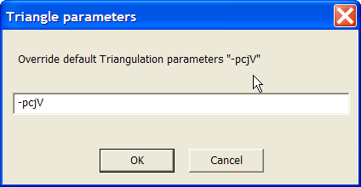  a) | 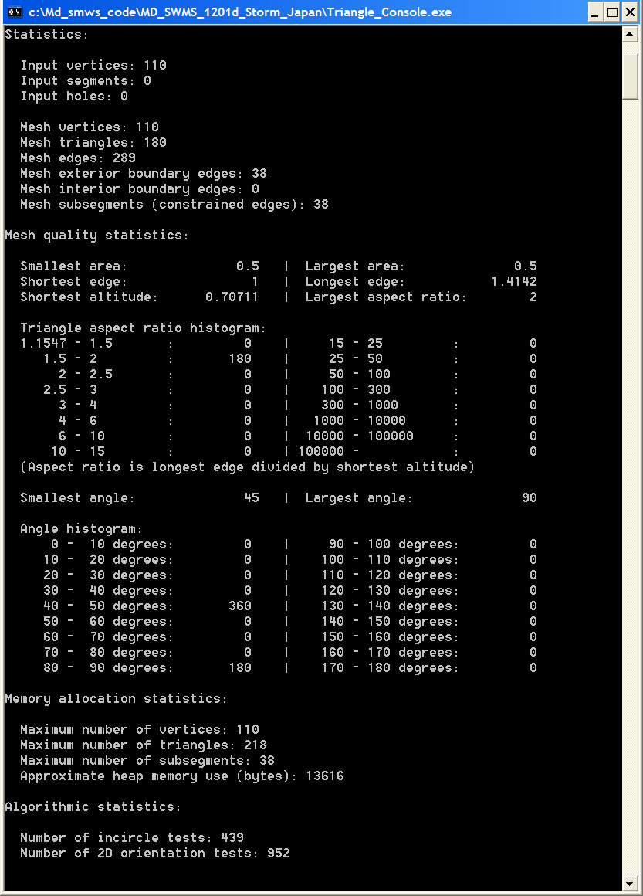  b)
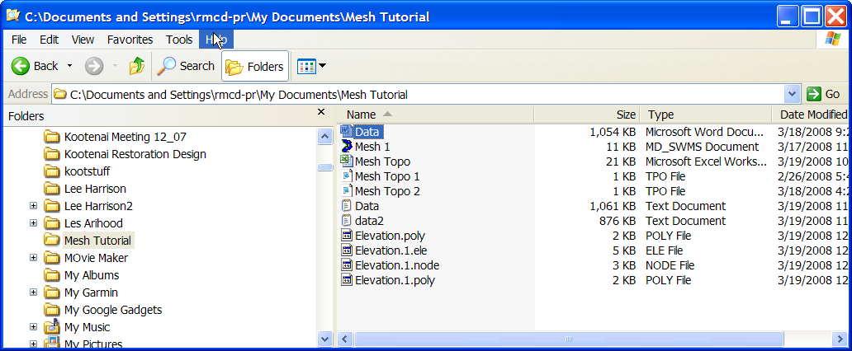  c) | 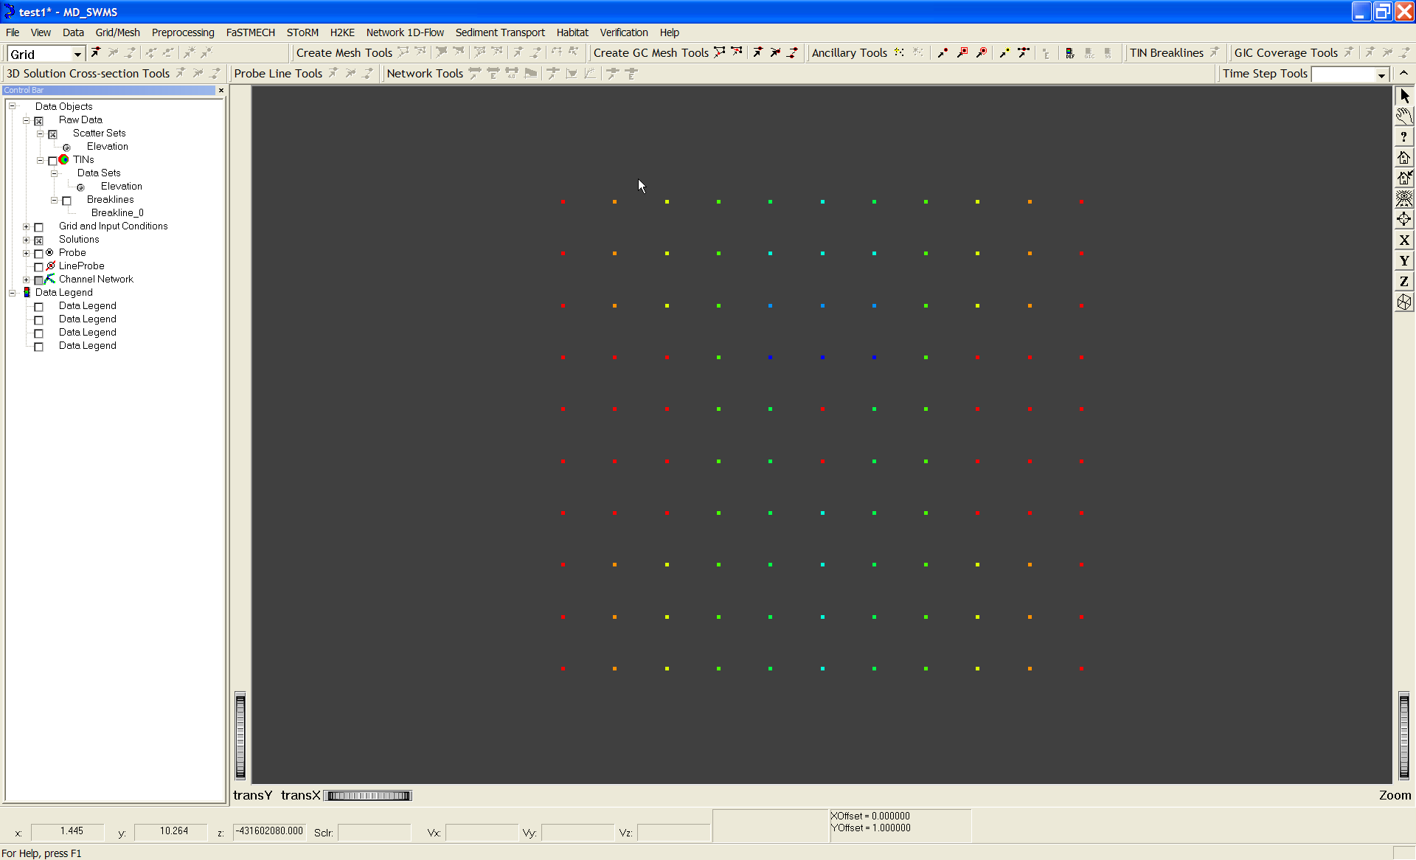  d)
Figure 6 a-d a) Options used by program Triangle; b) Triangle output; c) View of Mesh Tutorial folder with Triangle output files including: Elevation.poly, Elevation.1.node, Elevation.1.ele, and Elevation.1.poly; d) View of mesh tutorial topography

- Save the Project (for example, Mesh 1) by selecting File ->Save from the main menu.
- A triangulated grid of the raw data also can be viewed. In the control bar select Raw Data | TINs to turn the triangulated grid on. By default, the raw elevation data is triangulated (fig. 6e). The graphic attributes of the TINs can be changed by double-clicking on the Raw Data | TINs branch in the Control Bar. For a complete description of the graphic attributes for the TIN or any gridded scalar, see Section 2.1, Scalar Attritbutes.

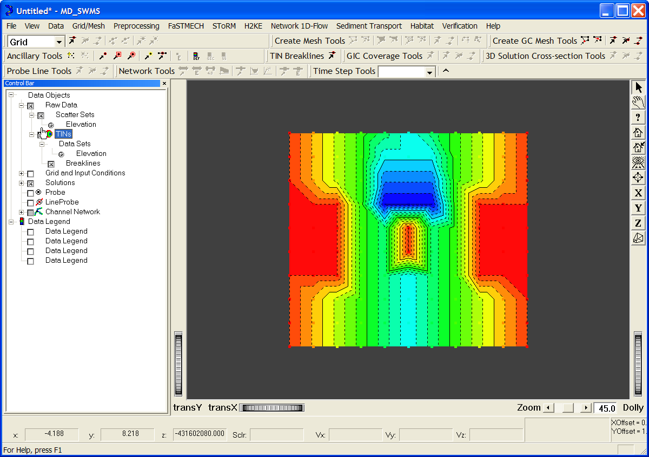
Figure 6e. View Topography as a Triangular Irregular Network Grid
- To view the data in 3D, from the main menu select View -> Examiner Viewer.
- To change the vertical scale select View->Set Vertical Scale and enter 10 in the Set Vertical Scale Dialog. Select the refresh button () to center the channel in the window.
- The location of the light source can be changed to add shadowing effects by selecting View -> Light Editor from the menu. To move the light source left click on the center of the Light Editor and drag to the desired position.
- Click the red check box at the upper right of the Light Editor to close.
- The Examiner Viewer is used for viewing data only; to get back to the Plane Viewer select View -> Plane Viewer from the menu.

Part B - Working with the Elevation TIN and Breaklines
We will be using the TIN of the elevation data set imported into MD_SWMS and triangulated with Triangle (in Part A) to map the measured elevations on to our mesh in Part C. Close inspection of the TIN from Part A Figure 6e reveals that the bridge abutments and scour hole are not symmetric with the center line of the channel (flow is from bottom to top). Before we use the TIN to map the measured elevations to the mesh, we would like to ensure that the TIN correctly reflects the geometry of the abutments and scour hole. The asymmetry is an artifact of the initial triangulation of the measured elevations, nevertheless, we can force symmetry with the use of breaklines. In this section of the tutorial we will look at how we can use breaklines to improve the TIN. Breaklines can be used to ensure that linear features and the edges of polygons are maintained in the TIN by forcing the edges of triangles in the TIN to follow the breakline. In Figure 6f, the mesh lines of the TIN created from the grid of points imported in Part A of this tutorial are shown. Note how the orientation of diagonal edges which form the triangles are somewhat randomly oriented and lead to the asymmetry of the resulting TIN. By placing breaklines to force the orientation of select diagonal edges in the TIN (Figure 6g) we build a resulting TIN that reflects the symmetry of the bridge abutments and scour hole.

f) 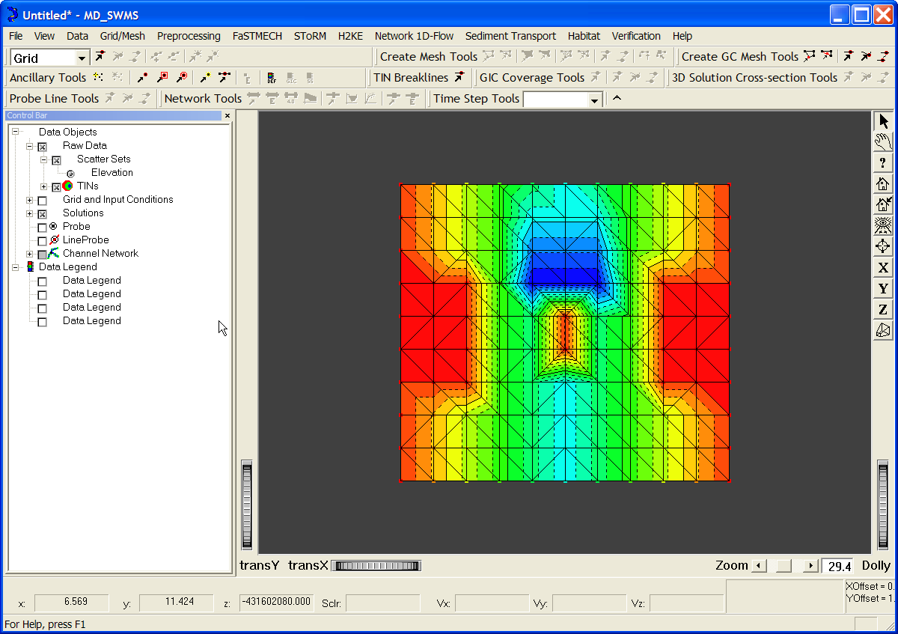
g) 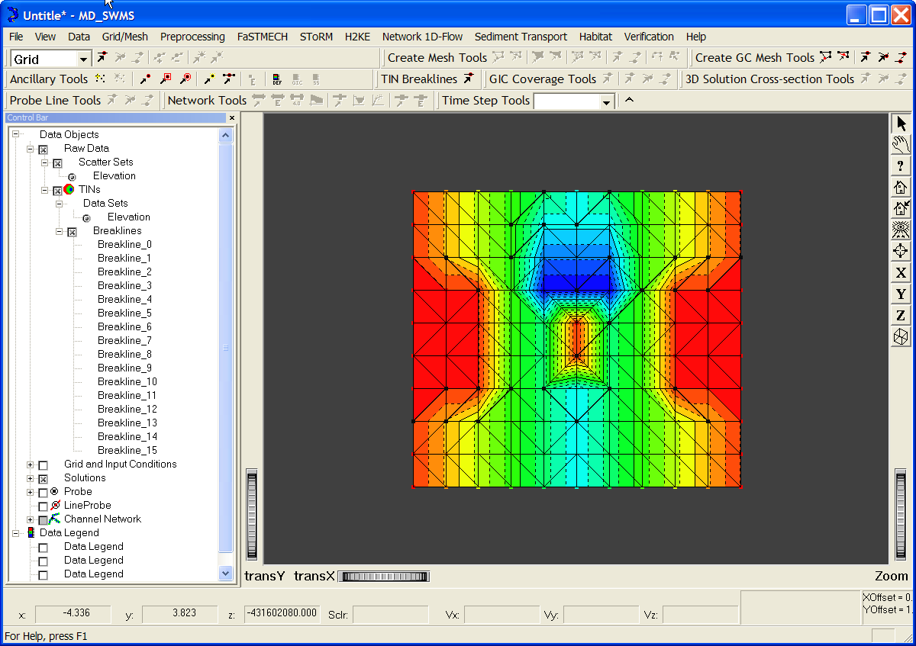
- 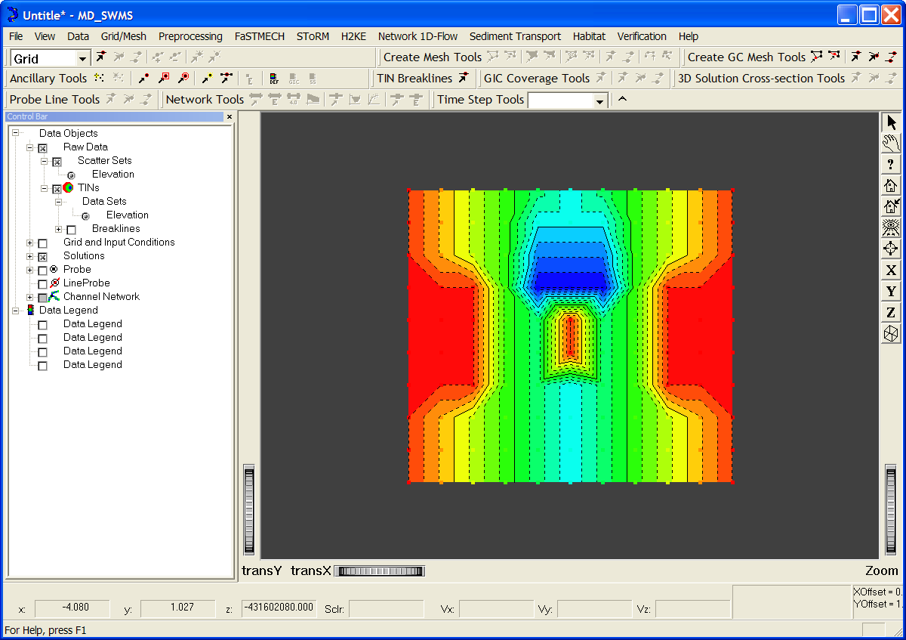

Figure 6 f-h f) TIN with the meshlines shown, g) TIN showing the breaklines used to force symmetry, h) resulting TIN including the use of breaklines.

In this part of Tutorial 1, we will become familiar with the Breakline Tool and Updating the TIN. The Breakline tool creates lines between two or more measured elevations. The TIN of the measured elevations can be updated at anytime to reflect either the addition of breaklines or additional imported elevation points.

- The TIN Breakline toolbar contains a single tool that can be used to create one or more breakline segments by left clicking the mouse on two or more elevation data points. Breaklines are lines representing a stream channel, ridge, bank, or other features that need to be preserved in a TIN. In the mesh generator, breaklines are treated as series of edges that the triangles must conform to. To better view the TIN so that we can select the appropriate points to create breakline segments we will first change the graphic attributes of the TIN so that the mesh lines of the TIN are visible. Using the mouse double click Raw Data | TIN in the Control Bar. In the Scalar Attributes dialog, select the General tab and turn on the Mesh Lines by selecting the check box. Next select the Mesh Lines tab and in the Color Mode properties drop-down menu select Constant. This will show the mesh lines of the TIN in black (Figure 6f).
- Using the TIN Breakline tool you will change the orientation of the diagonal mesh lines of the TIN as in Figure 6g so that the bridge abutments, bridge pier, and scour hole are symmetrical with the channel centerline. To create a breakline select the TIN Breakline tool and select two or more nodes of the TIN by left clicking the mouse on the node. To Update the TIN, from the menu choose Data->Raw Data TIN->Update Triangulation. In the Triangle Parameters dialog use the default parameters. You will see that the Raw Data | TIN | Breaklines branch of the tree now has a Breakline_0 added. In the Control Bar you can turn the breaklines on or off to see that mesh lines of the TIN conform to the breakline. If you are unsatisfied with the results of the breakline you can right-click on Breakline_0 and select Delete from the pop-up menu and then update the TIN again using the Update Triangulation menu command as in the previous step.
- Continue creating breaklines and updating the TIN until you have a something similar to Figure 6h.

Part C - Meshing Tools
The MD_SWMS Meshing Tools toolbar provide a suite of tools that are used to define a mesh boundary, mesh holes, mesh line constraints, or mesh refinement polygons. In this tutorial we will experiment with these tools to build increasingly refined unstructured meshes. For the simplest unstructured mesh all that is required is a mesh boundary and a set of input parameters including a minimum angle and maximum area constraint. This mesh can then be refined with the addition of constraint lines to specifically represent the geometry of the bridge abutments, followed by a hole to represent the bridge pier and finally local refinements to the size of the triangles around the bridge pier and abutments. In a manner similar to the way MD_SWMS provides a set of tools for interfacing with the program Triangle for building Delaunay triangulations or TINs of measured data such as elevation, MD_SWMS' Meshing Tools interface with Triangle's ability to build constrained conforming Delaunay triangulations (CCDT). As with MD_SWMS’ other mesh and grid building tools, we will first define the mesh and then map measured elevations to it using the TIN of the measured elevation. It is recommended that you read through Section 1.4.6 Create Mesh Toolbar as you work through this section of the toolbar.

Building a simple unstructured mesh
- Activate the Create Mesh Tool by selecting from the menu, Grid/Mesh -> 2D Unstructured Mesh. This will add the Create Mesh branch to the Grid and Input Conditions branch of the data tree in the Control Bar.
- An unstructured mesh is created by first defining the mesh boundary in the region you would like to model using the Create Mesh Boundary tool . Click this button and draw a polygon defining the grid boundary. Make sure that the polygon is contained within the area for which topography data is available. Hit enter when done. The mesh is then created in the following steps:
  - Right click on Grid and Input Conditions | Create Mesh (Figure 2) in the Control Bar and select Create Mesh from the pop-up menu.
  - If this is the first time the Create Mesh command is used (otherwise skip to step 3) then the Choose Mesh Name and Location dialog will appear. Browse to an appropriate location (such as the folder containing the topography data) and then enter the name of the file used as input to the Triangle tool. A good choice might be "Mesh" for the name of the file. The .poly extension is added to the file by default.
  - Following step 2, the Create Mesh Dialog will appear (Figure 3). This dialog allows you to specify parameters for angle and area constraints. You must check the boxes associated with each if you would like them to apply. The quality meshing constraint imposes a minimum angle for each triangle and the area constraint imposes a maximum area for each triangle (Table 1). Select both the angle and area constraints and enter 32.5 degrees and 0.5 m² for their values, respectively.
  - At this point the spatial location and geometry of the mesh has been defined but there are no input conditions associated with it, so you will want to map the topography to the grid (see section 1.5.4 Preprocessing Menu).
  - From the menu select Preprocessing -> Set Current Input Condition -> Map w/TIN. The resulting elevation mapped to the mesh is shown in Figure 6i. The combination of discretizing the mesh space with rather large and arbitrarily spaced triangles results in a rather poor representation of the topography. This can be remedied by re-creating the mesh with a very small maximum area constraint such as 0.005 m² and following steps 3 - 6 to create the mesh and re-map the topography. The resulting mesh topography is a much better representation of the channel you would like to model.

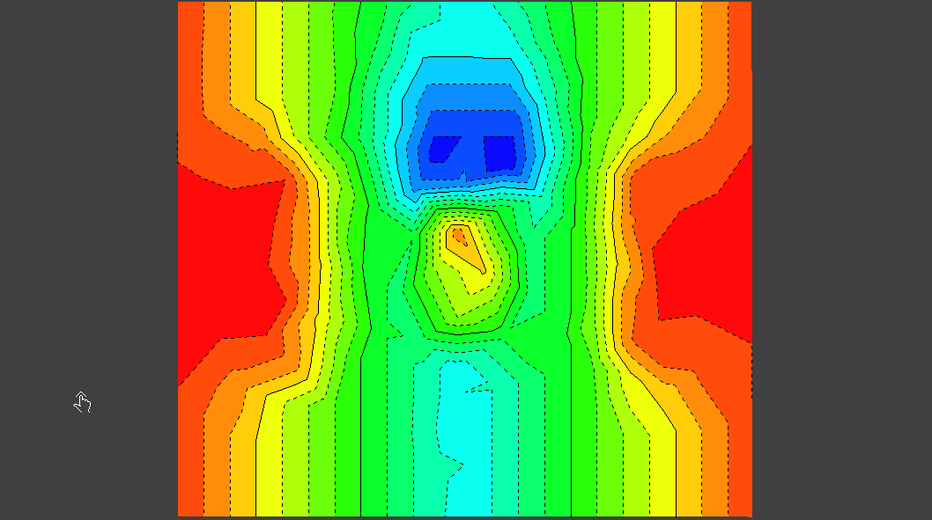  i) | 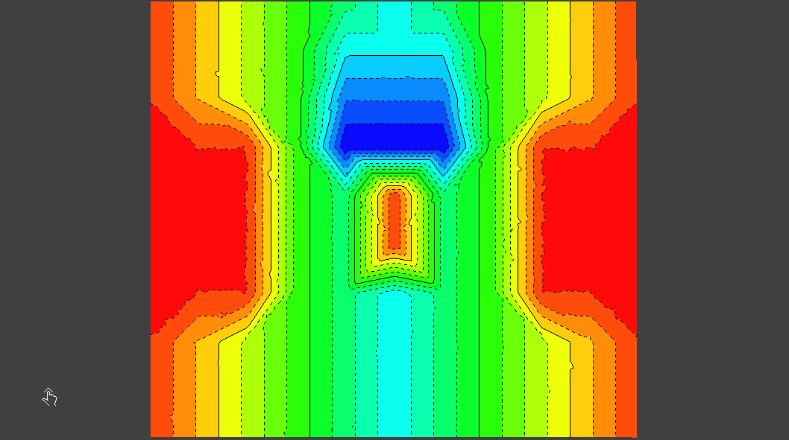  j)
Figure 6 i-j: The meshes mapped elevation is shown for two mesh area constraints: 0.5 m² and 0.005m²

Refining the Mesh
Simply creating a fine mesh is a simple way to overcome the difficulties of discretization. This can have a huge cost computationally as the computation time goes as something like number of nodes squared. The mesh in figure 6i contains approximately 300 nodes while that in figure 6j contains approximately 30,000 nodes. If the model took 10 minutes to get to equilibrium in the coarse mesh it would take 62 days in the fine mesh! So clearly you would like to find a way to balance the number of nodes in the mesh with the ability to better represent the geometry of the channel you are trying to model. Using mesh constraints we can define the edges of the bridge abutments and pier explicitly and get a much better representation of the topography.

- Recreate the mesh with a maximum area constraint of 0.5, following steps 3 and 4 above.
- In the Control Bar, turn everything off except for the Raw Data | Scatter Sets | Elevation , Grid and Input Conditions | Create Mesh and Grid and Input Conditions | Create Mesh | Mesh Constraints, which will give a clear view of the data points that define the bridge abutments and pier (Figure 6k).
- Select the Mesh Constraint Tool in the Create Mesh Toolbar and following the elevation scatter points that define the edge of the bridge abutments draw a constraint line, selecting Enter when finished. Do this for both bridge abutments and the two points representing the bridge pier as shown in Figure 6k.
- Recreate the mesh again as in step 7. Then map the topography to the mesh as in step 6 (Figure 6l). The result is a much better representation of the topography using essentially the same number of nodes as shown in Figure 6i.
- We can improve upon this with minor adjustments to the mesh. Add a new constraint in the scour hole as shown in Figure 6m. Recreate the mesh again with a maximum area of 0.25 and then re-map the topography to the mesh. The result is a fine balance between the number of nodes in the mesh and a good representation of the topography.

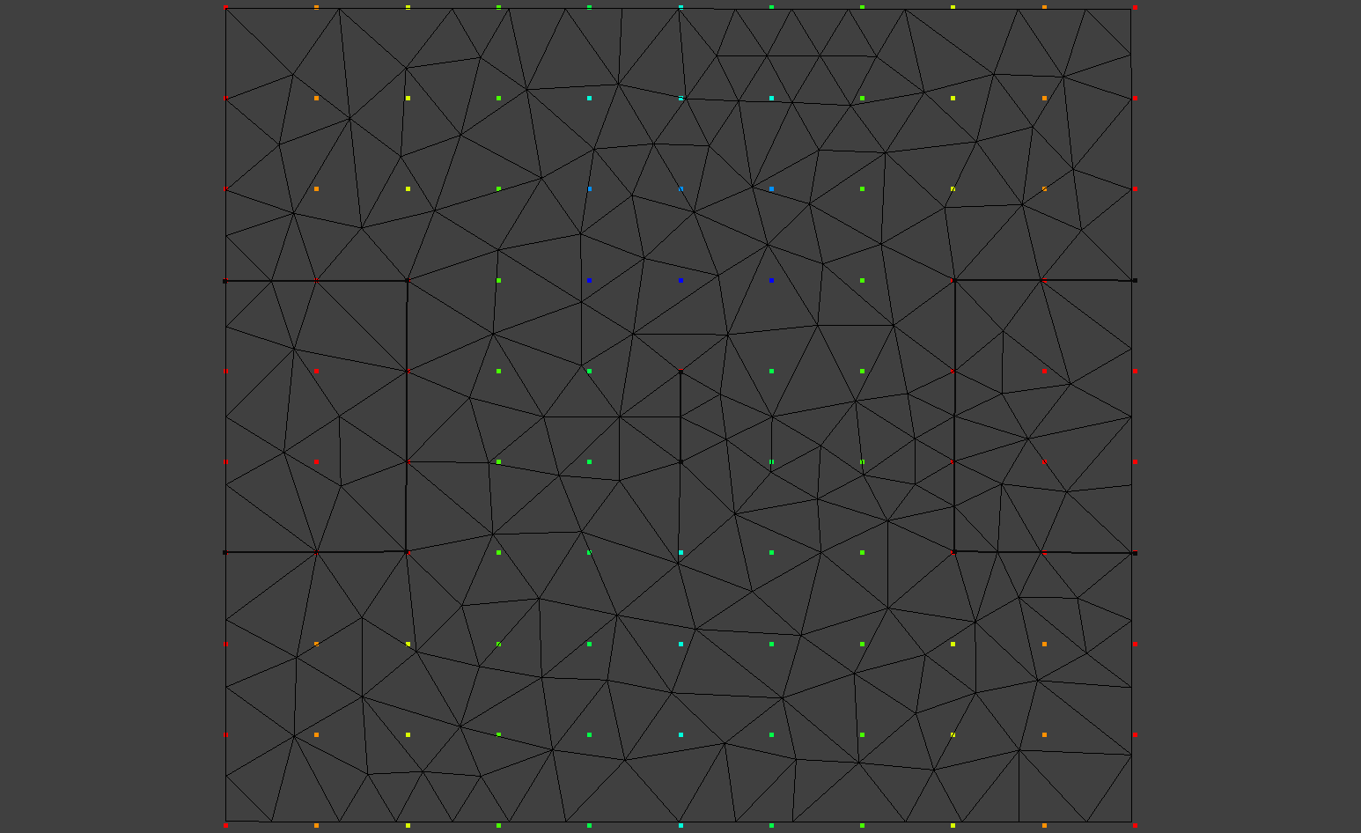  k) | 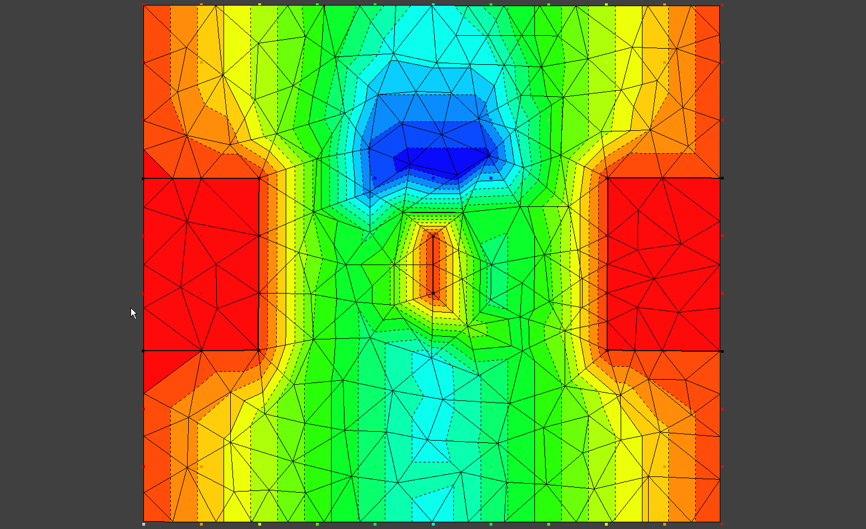  l)
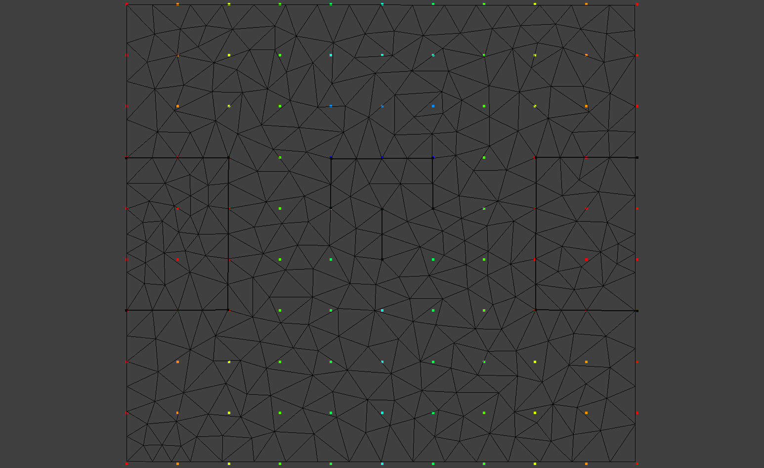  m) | 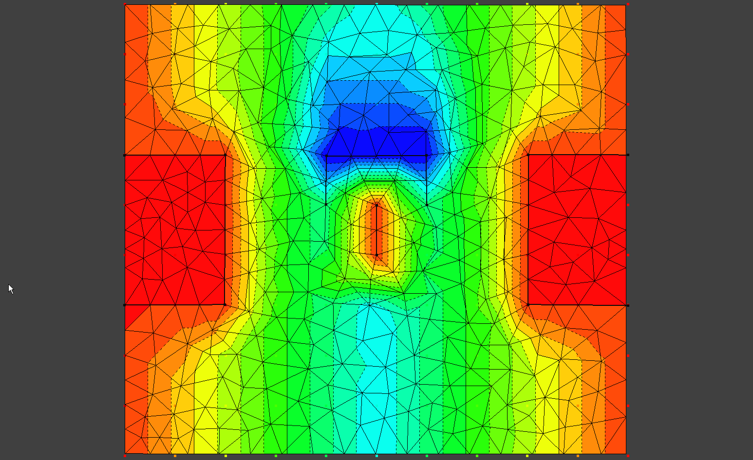  n)
Figure 6 k-n Using constraint lines to optimize the location of cell edges (i) to better map the bridge abutments and pier. The resulting topography as mapped to the mesh is a better representation of the topography as represented in the TIN with breaklines. Further refining the grid with a mesh constraint around the leading edge of the scour hole (m), and a small decrease in the maximum cell area from 0.5 to 0.25 m² leads to an even better representation of the topography with only a small cost in extra nodes: 341 compared to 323 for the case with maximum area of 0.5.

Part D - Defining Boundary Conditions
With topography mapped to the mesh you are ready to specify boundary conditions using the Nodestring Tool . Boundary conditions are specified by first creating nodestrings representing the inflow and outflow boundary and then specifying the boundary condition properties associated with each nodesting. For example, specifying the boundary condition's type (Discharge or Stage) whether its steady or unsteady and if unsteady the time-series or rating-curve associated with it. The following steps create boundary conditions for the case you are modeling here.
- Using the Nodestring Tool, left click on nodes of the mesh, from one end of the boundary to the other, using the left mouse button and selecting Enter when finished. Notice that the location of the node you are selecting with the mouse snaps to the nearest node. Create the Discharge nodestring first followed by the Stage nodesting. Be aware that SToRM will stop with an error if you skip a node along the nodestring. After creating a nodestring if you find you made a mistake you can delete the nodestring by right clicking on the nodes string in the Control Bar (for example, Grid and input Condition | Create Mesh | Mesh Node Strings | Nodestring_0 and selecting Delete in the pop-up menu.
- Using Mannings Equation estimate the Discharge when the stage is 9 meters and the slope of the channel is 10⁻⁴.
Q = VA
V = (A/P)^{2/3}S^{1/2}n⁻¹
Q = discharge
A = area
V = velocity
P = wetted perimeter
S = slope.
- To define the boundary condition properties associated with the nodestring, right click on Grid and input Condition | Create Mesh | Mesh Node Strings | Nodestring_0 and in the pop-up menu select Assign Boundary Condition. In this case both the Discharge and Stage are steady, so you will enter their values in the Steady Value field as shown in Figure 6 p and q.
Before we can move on to modeling this channel we need to set the value of the roughness in the input condition. We'll be using Mannings n for roughness. In the menu select Preprocessing->Set Roughness Input Condition->Set Constant. In the Set Roughness Constant dialog enter 0.035.

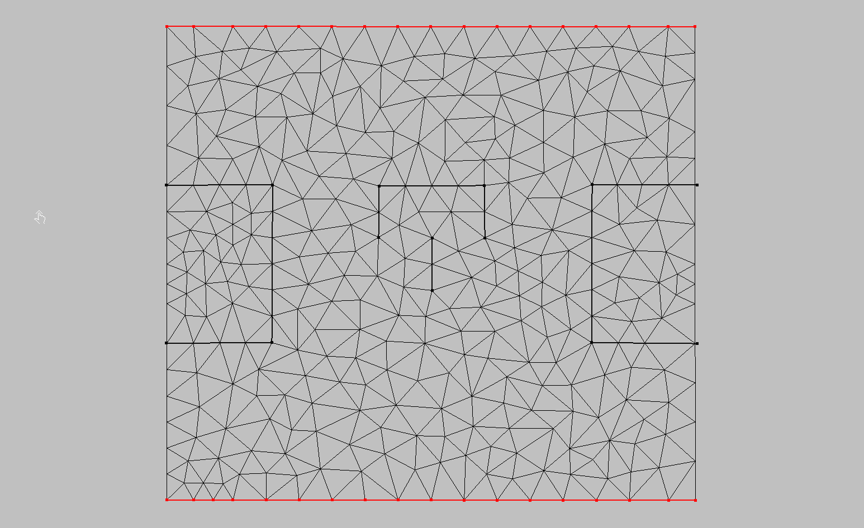
o)
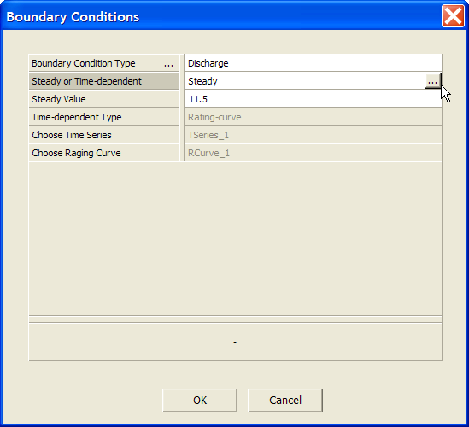  p) | 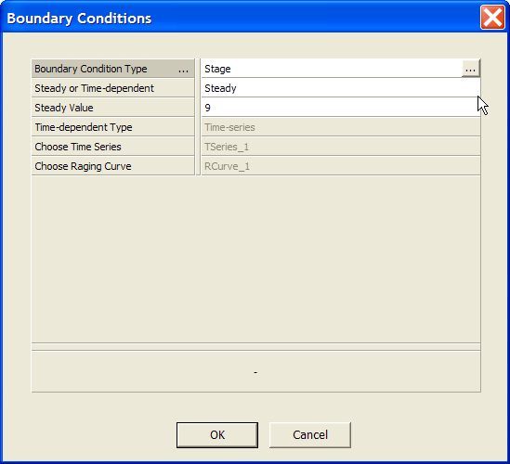  q)
Figure 6 o-q Mesh with nodestings representing the mesh discharge and stage boundary conditions (o). The boundary conditions are specified in the Boundary Conditions dialog (p & q).

Part E - Running SToRM
Given Input Conditions of Elevation and Roughness, and Boundary Conditions of Stage and Discharge we have everything we need to run SToRM. The following section gives a brief introduction to SToRM’s model parameters and the process of running SToRM.
Figures 6 r-w give all the model parameters we will use to run SToRM for this simple case. To create a model run:
- Create a new simulation file for SToRM. From the menu select SToRM->Create Simulation and enter a name for the simulation.
- Edit the model parameters. From the menu select SToRM->Edit Input File and enter the values as shown in Figure 6 r-w.
- The Solutions tab requires a bit of explanation related to the Import Mesh Files 2 button. Every time you open the SToRM Parameters dialog with the Edit Input File menu command you will have to reselect the mesh files as follows. Select the Import Mesh Files 2 Button. In the Open File Dialog enter "*.edge" without the quotes in the File Name field and then hit Enter. This bring all the files that end in .edge into view. It is very important that you select the file with the .edge extension and not the file with the .v.edge extension as shown in Figure 6x.
- When all the parameters are enter as shown to run SToRM select from the Menu SToRM->Run. When the run is finished you will have to select Enter in the SToRM’s Console window.
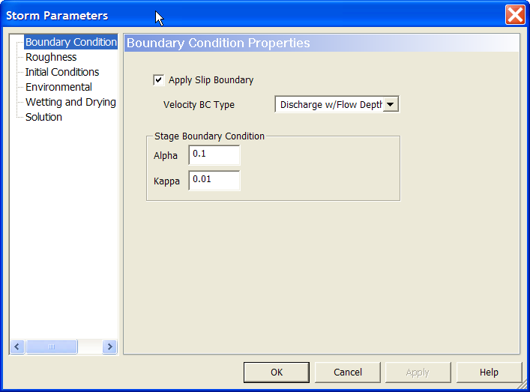  r) | 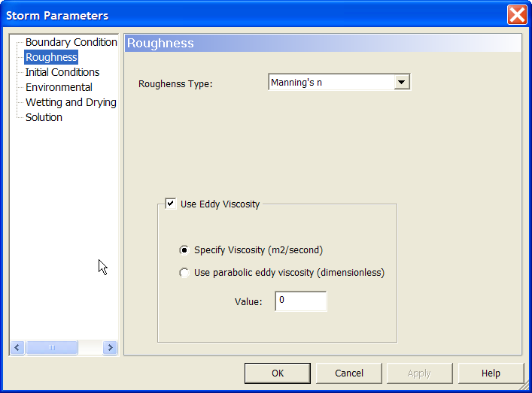  s)
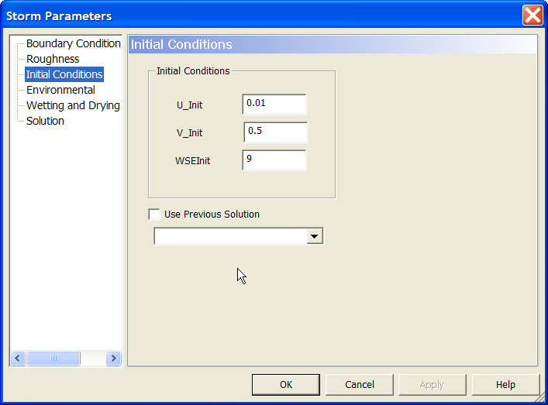  t) | 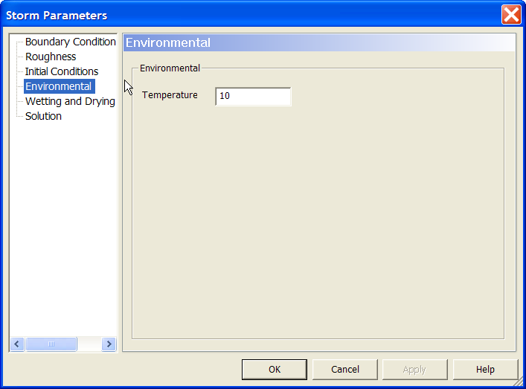  u)
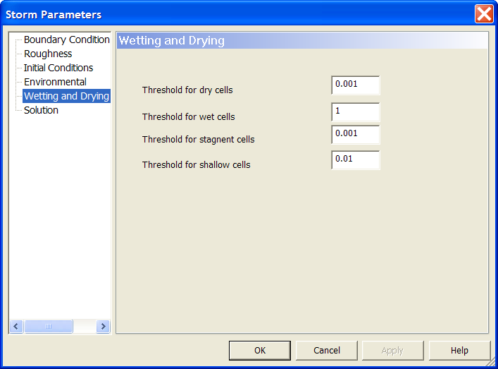  v) | 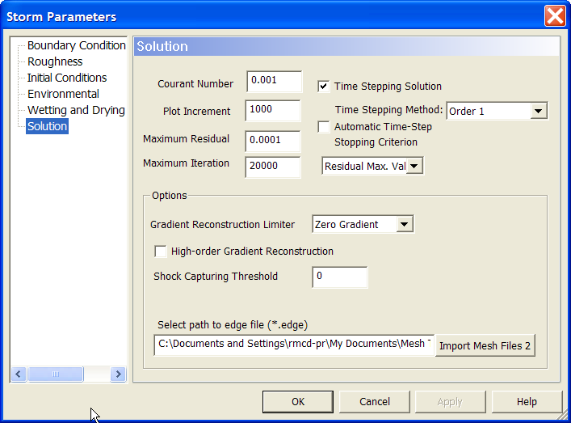  w)
Figure 6 r-w: The Storm Parameters Dialog

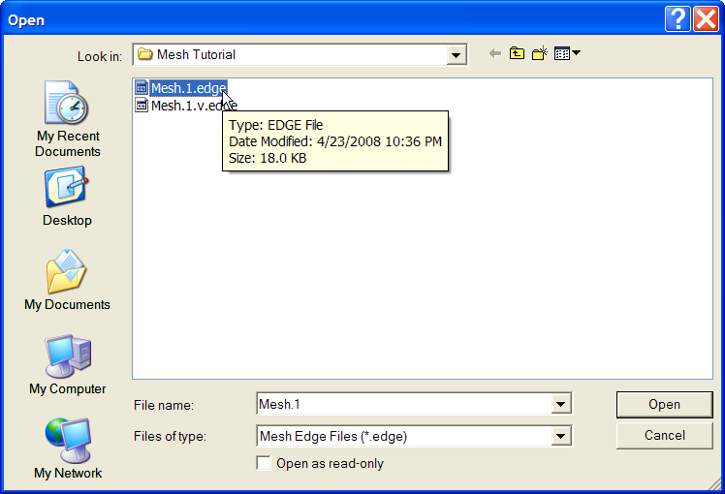
x)
Figure 6x In the Solutions tab of the Storm Parameters dialog, make sure that the path to the *.edge is selected. To find the .edge files enter *.edge into the File name field and select Enter. This will bring all the files with .edge as an extension into view. It is very important that you select the file with the .edge extension and not the file with the .v.edge extension.

Part F - Visualize Results
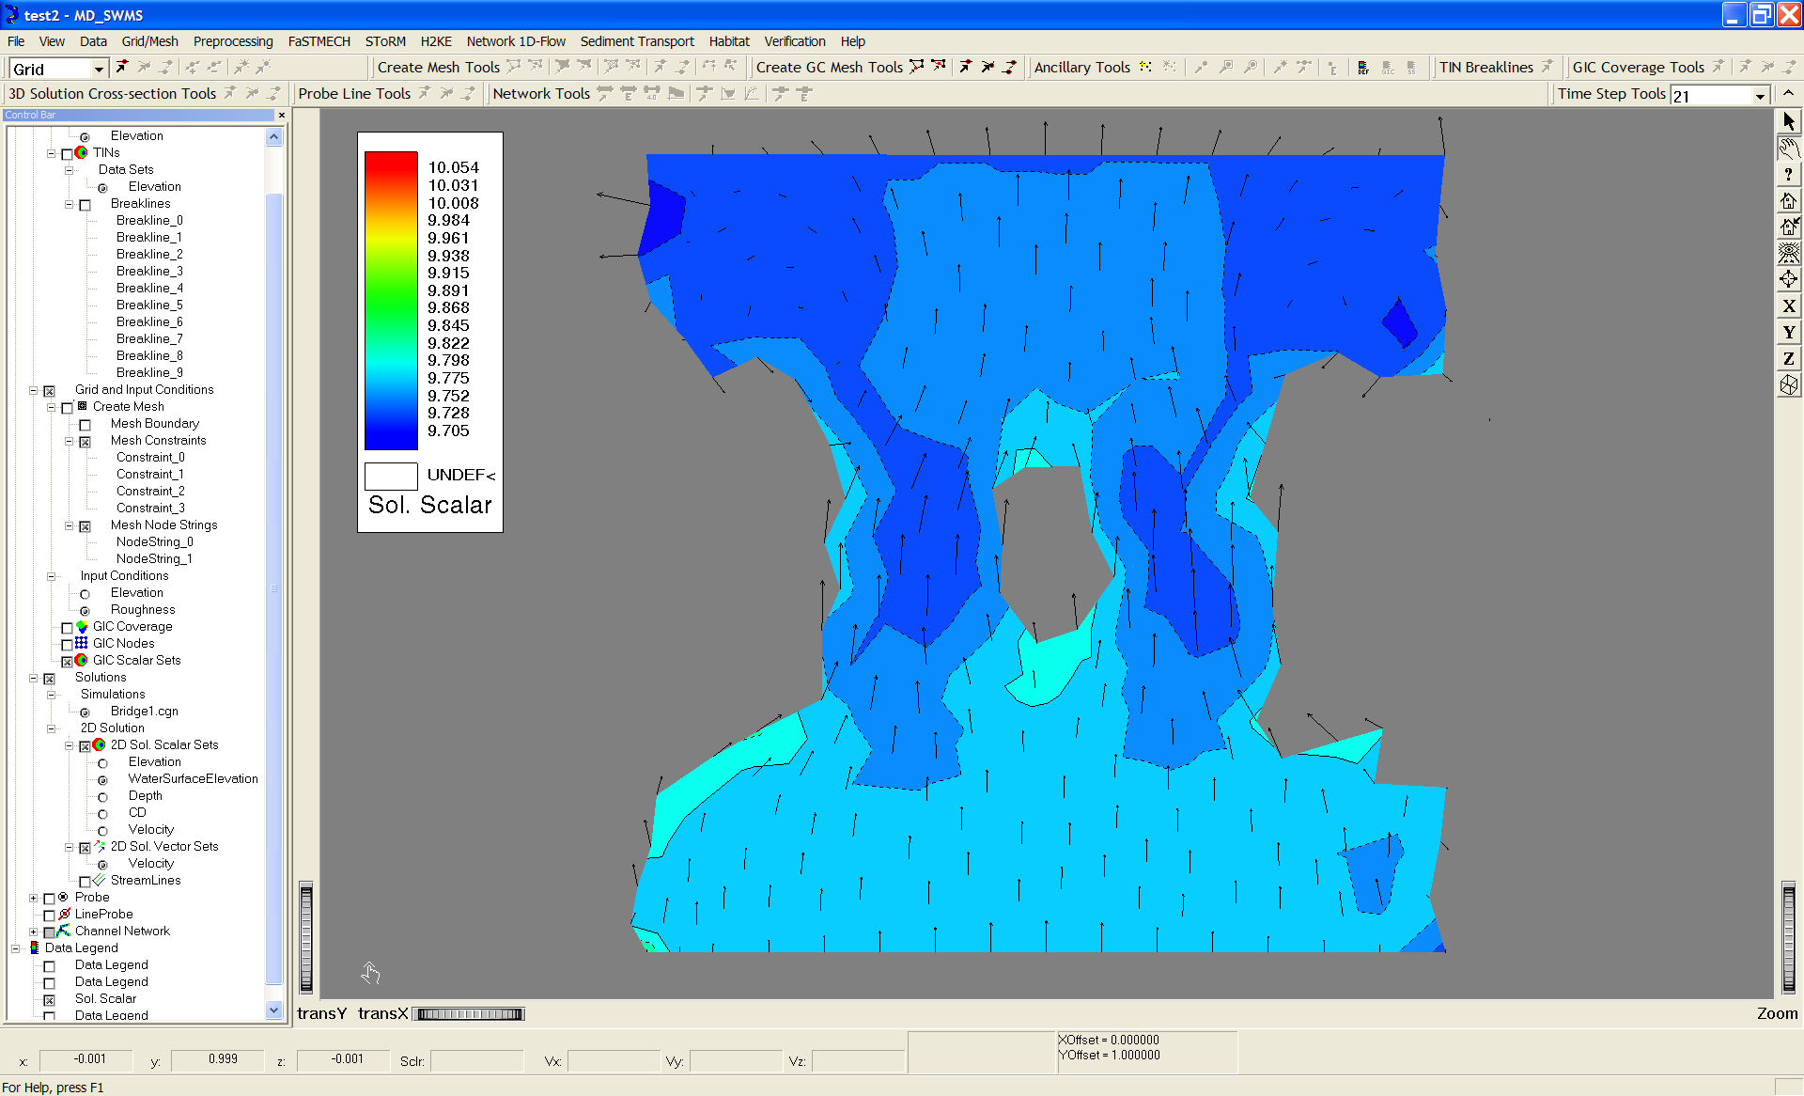
y)
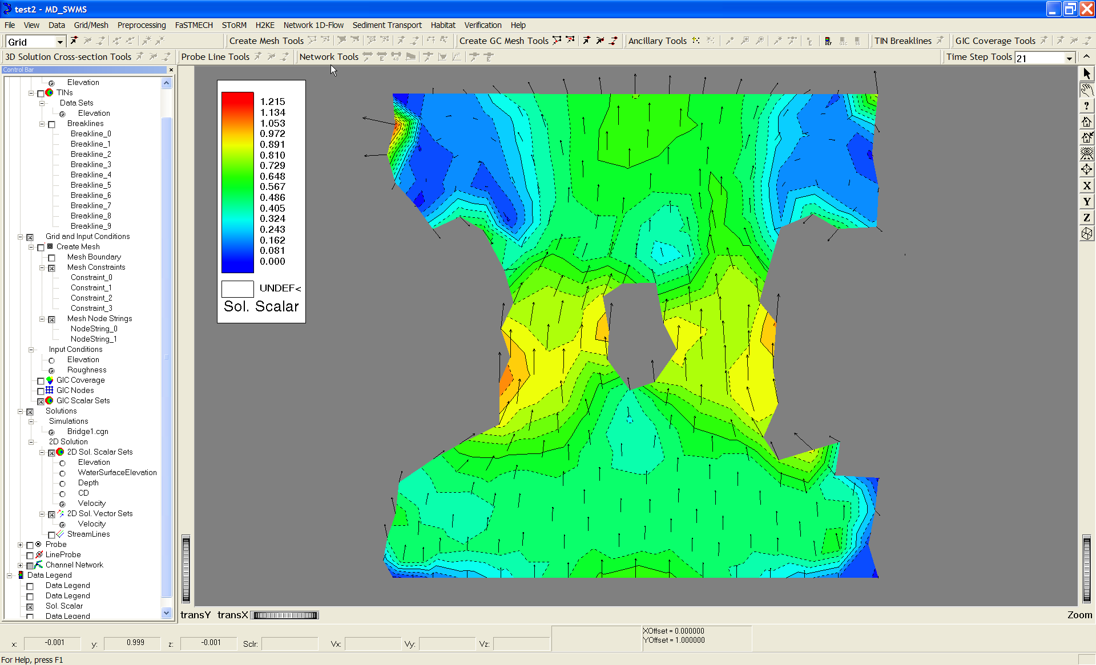
z)
Figure 6 y-z: SToRM solution showing velocity vectors with water surface elevation (y) and velocity magnitude(z) in the background

